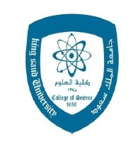
جامعة الملك سعود
كلية العلوم
المختبر المركزي

- NCG Next Generation Chromatography (BIO-RAD)

Supervised by: Central Lab. and Al-Jeel Company
Date and Place: 25 Oct, 2015 Rom AA90 Building 5
Speaker : DR: Jerzy Jankowski
Time: 9.00 AM – 2.00 PM

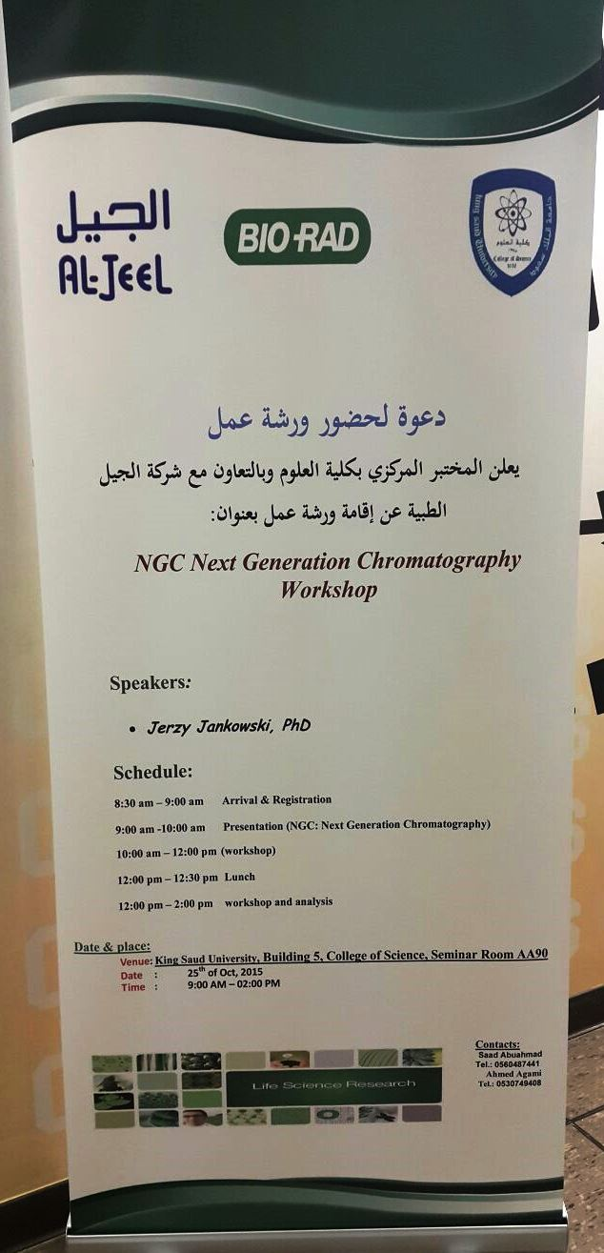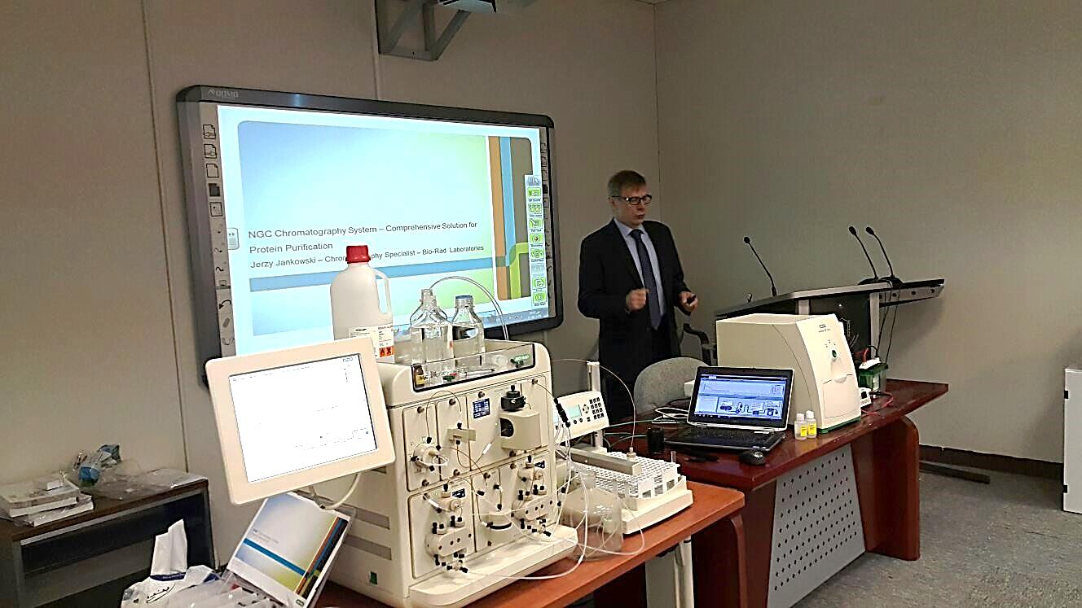

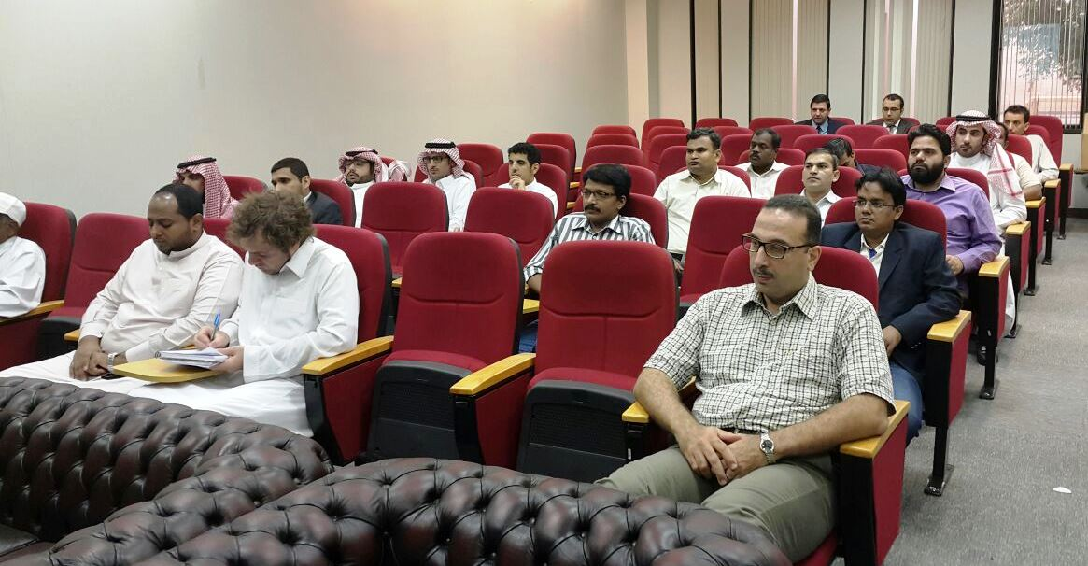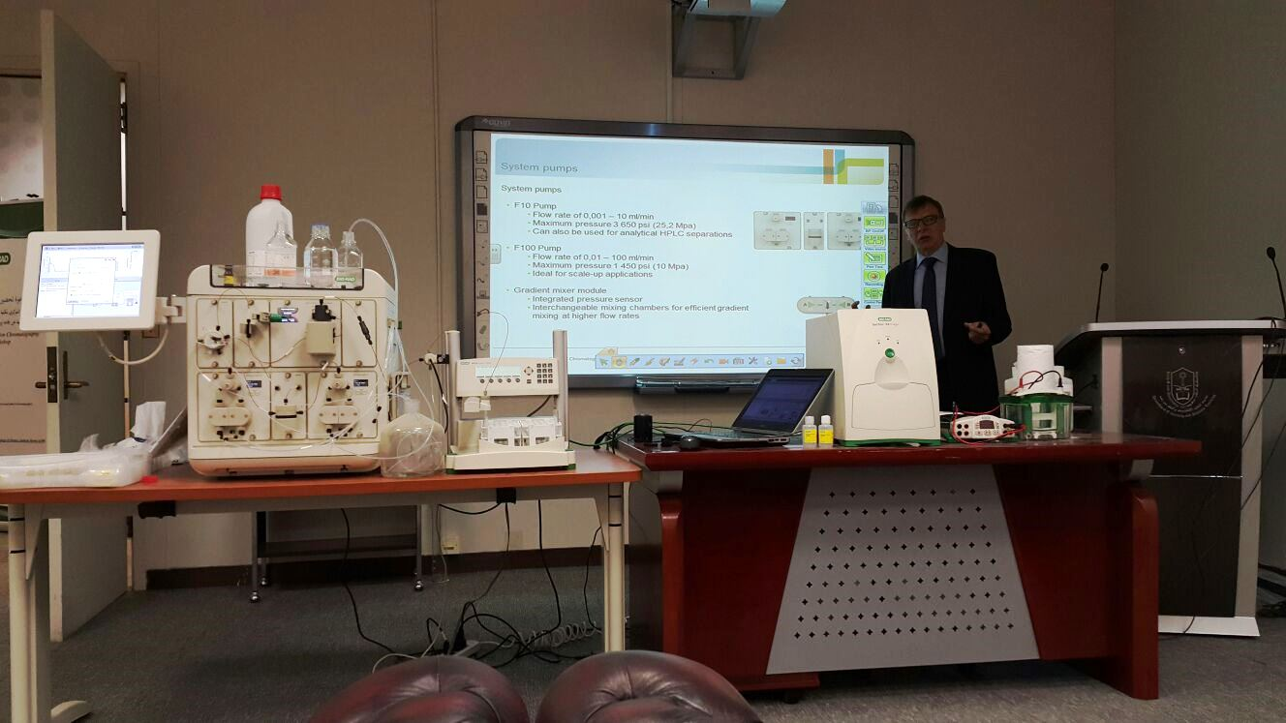

- Helios a Cy TOF system

Supervised by: Central Lab. and Golf scientific Company
Date and Place: 16 Nov, 2015 Rom AA90 Building 5
Speaker : DR: Alexander Darmoise
Time: 10.00 AM – 12.00 PM

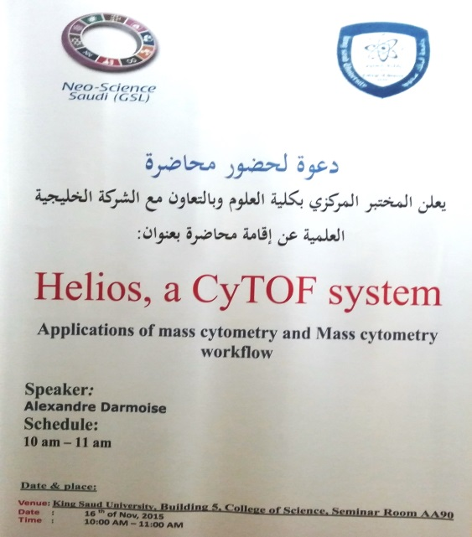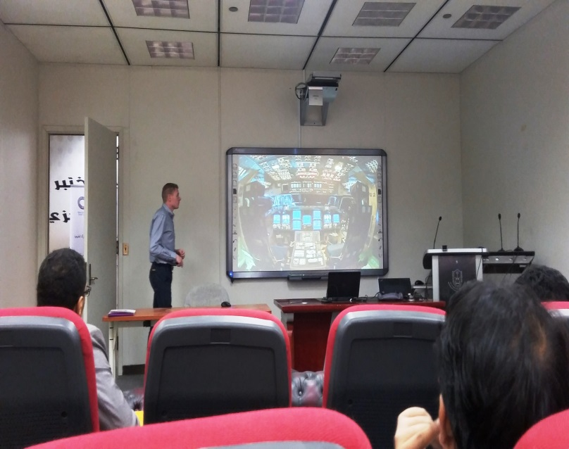

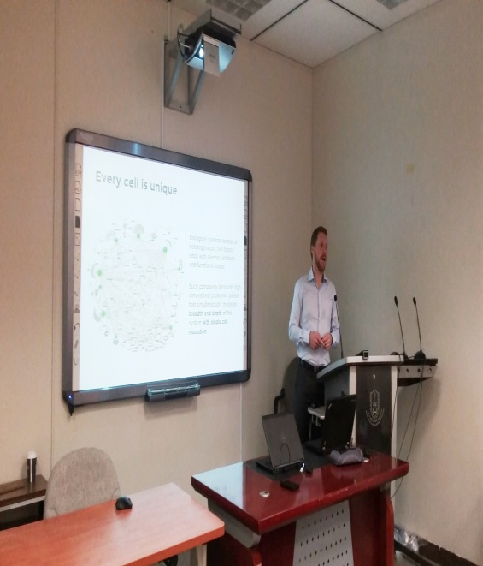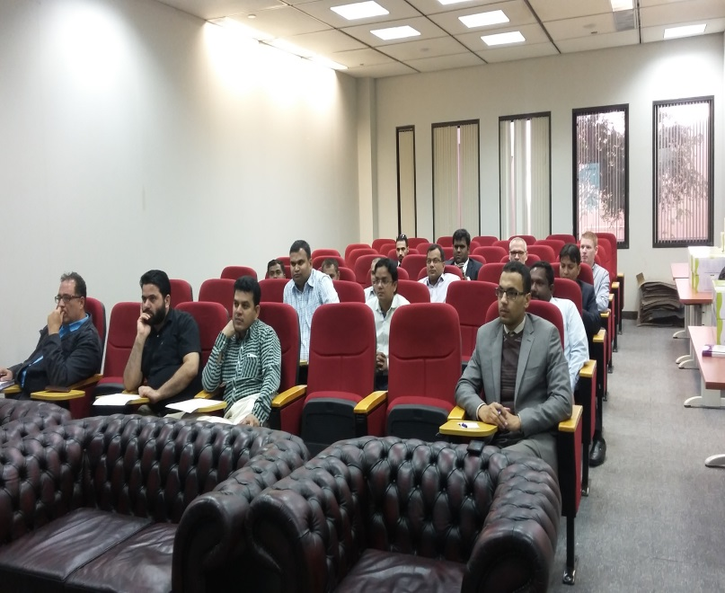

- Motic Digital Microscopy
(Imaging Advancement for Education & Research)

Supervised by: Central Lab. and El Sana Company
Date and Place: 7 Dec, 2015 Rom AA90 Building 5
Speaker : Patrick Pek
Time: 10.00 AM – 12.00 PM

